13. Scenario: You are working on a text analysis project and need to determine the frequency distribution of words in a given text document. You have a text document named "sample_text.txt" containing a paragraph of text. Your task is to develop a Python program that reads the textdocument, processes the text, and generates a frequency distribution of the words.
Question: How would you develop a Python program to calculate the frequency distribution of words in a text document?
Code:
from collections import Counter
with open("sample_text.txt", "w") as f:
f.write("Python is easy. Python is useful.")
with open("sample_text.txt", "r") as f:
text = f.read().lower()
words = text.replace(".", "").split()
freq = Counter(words)
print(freq)
Output:
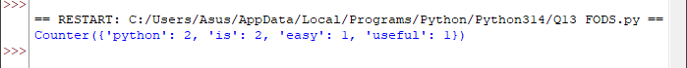
14. Scenario: You are a data analyst working for a company that sells products online. You have been tasked with analyzing the sales data for the past month. The data is stored in a Pandas data frame.
Question: Develop a code in python to find the frequency distribution of the ages of the customers who have made a purchase in the past month.
Code:
import pandas as pd
df = pd.DataFrame({"Age": [20, 25, 20, 30, 25, 20]})
print(df["Age"].value_counts().sort_index())

Output:
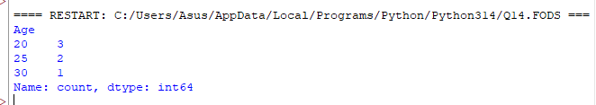
15. Scenario: You are a data analyst working for a social media platform. As part of your analysis, you have a dataset containing user interaction data, including the number of likes received by each post. Your task is to develop a Python program that calculates the frequency distribution of likes among the posts.
Question: Develop a Python program to calculate the frequency distribution of likes among the posts?
Code:
from collections import Counter
likes = [10, 20, 10, 30, 20, 10]
freq = Counter(likes)
print(freq)
Output:
16. Scenario: You are working on a project that involves analyzing customer reviews for a product. You have a dataset containing customer reviews, and your task is to develop a Python program that calculates the frequency distribution of words in the reviews.
Question: Develop a Python program to calculate the frequency distribution of words in the customer reviews dataset?
Code:
from collections import Counter
reviews = ["Good product", "Good quality", "Nice product"]
words = " ".join(reviews).lower().split()
freq = Counter(words)
print(freq)
Output:
17. Scenario: You are a data analyst working for a marketing research company. Your team has collected a large dataset containing customer feedback from various social media platforms. The dataset consists of thousands of text entries, and your task is to develop a Python program to analyze the frequency distribution of words in this dataset. Your program should be able to perform the following tasks:
- Load the dataset from a CSV file (data.csv) containing a single column named "feedback"with each row representing a customer comment.
- Preprocess the text data by removing punctuation, converting all text to lowercase, and eliminating any stop words (common words like "the," "and," "is," etc. that don't carry significant meaning).
- Calculate the frequency distribution of words in the preprocessed dataset.
- Display the top N most frequent words and their corresponding frequencies, where N is provided as user input.
- Plot a bar graph to visualize the top N most frequent words and their frequencies.
Question: Create a Python program that fulfills these requirements and helps your team gain
insights from the customer feedback data.
Code:
import pandas as pd
import re
import matplotlib.pyplot as plt
from collections import Counter
df = pd.DataFrame({
"feedback": [
"Good product and good quality",
"The product is nice",
"Good service and nice product" ]
})
df.to_csv("data.csv", index=False)
df = pd.read_csv("data.csv")
stop = {"the", "and", "is", "a", "to", "of", "in"}
words = []
for text in df["feedback"].dropna():
text = re.sub(r"[^\w\s]", "", text.lower())
words.extend(w for w in text.split() if w not in stop)
freq = Counter(words)
n = int(input("Enter N: "))
top = freq.most_common(n)
print("Word Frequencies:", top)
if top:
w, c = zip(*top)
plt.bar(w, c)
plt.xlabel("Words")
plt.ylabel("Frequency")
plt.title("Top Frequent Words")
plt.xticks(rotation=45)
plt.tight_layout()
plt.show()

OUTPUT:
